Assignment 4
Name: Parth Koshti
PRN: 24070126093
Batch: AIML B1

Title: Vector Operations Program: Implement 2D/3D vector addition, subtraction, and dot product with exception handling.

Code 1) Vector
public class Vector {
private double[] components;

public Vector(double[] components) {
if (components == null || (components.length != 2 && components.length != 3)) {
throw new IllegalArgumentException("Vector must have 2 or 3 components.");
}
this.components = components.length == 2 ? new double[2] : new double[3];
System.arraycopy(components, 0, this.components, 0, this.components.length);
}

private void checkDimension(Vector other) throws VectorException {
if (this.components.length != other.components.length) {
throw new VectorException("Vectors must have the same dimension.");
}
}

public Vector add(Vector other) throws VectorException {
checkDimension(other);
double[] result = new double[this.components.length];
for (int i = 0; i < this.components.length; i++) {
result[i] = this.components[i] + other.components[i];
}
return new Vector(result);
}

public Vector subtract(Vector other) throws VectorException {
checkDimension(other);
double[] result = new double[this.components.length];
for (int i = 0; i < this.components.length; i++) {
result[i] = this.components[i] - other.components[i];
}
return new Vector(result);
}

public double dot(Vector other) throws VectorException {
checkDimension(other);
double result = 0;
for (int i = 0; i < this.components.length; i++) {
result += this.components[i] * other.components[i];
}
return result;
}

@Override
public String toString() {
StringBuilder sb = new StringBuilder();
sb.append("(");
for (int i = 0; i < components.length; i++) {
sb.append(components[i]);
if (i < components.length - 1) {
sb.append(", ");
}
}
sb.append(")");
return sb.toString();
}
}

Code 2) Vector Operations
import java.util.Scanner;

public class VectorOperations {
public static void main(String[] args) {
try {
double[] v1 = {1, 2};
double[] v2 = {2, 3};
double[] v3 = {1, 2, 3};
double[] v4 = {2, 3, 4};
double[] v5 = {1, 2, 3, 4};
double[] v6 = {1, 2, 3};
double[] v7 = {4, 5};

Vector vector1 = new Vector(v1);
Vector vector2 = new Vector(v2);
Vector vector3 = new Vector(v3);
Vector vector4 = new Vector(v4);
Vector vector5 = new Vector(v5);
Vector vector6 = new Vector(v6);
Vector vector7 = new Vector(v7);

Vector sum_2D = vector1.add(vector2);
Vector diff_2D = vector1.subtract(vector2);
double dot_2D = vector1.dot(vector2);

Vector sum_3D = vector3.add(vector4);
Vector diff_3D = vector3.subtract(vector4);
double dot_3D = vector3.dot(vector4);

Vector sum_Exp = vector6.add(vector7);

System.out.println("v1: " + vector1);
System.out.println("v2: " + vector2);
System.out.println("v3: " + vector3);
System.out.println("v4: " + vector4);
System.out.println("Addition (2D): " + sum_2D);
System.out.println("Subtraction (2D): " + diff_2D);
System.out.println("Dot Product (2D): " + dot_2D);
System.out.println("Addition (3D): " + sum_3D);
System.out.println("Subtraction (3D): " + diff_3D);
System.out.println("Dot Product (3D): " + dot_3D);
} catch (VectorException e) {
System.out.println("Error: " + e.getMessage());
} catch (Exception e) {
System.out.println("Invalid input.");
}

}
}

Code 3) VectorException
public class VectorException extends Exception {
public VectorException(String message) {
super(message);
}
}

Code 4) validateSameDimension

public class validateSameDimension extends Exception {
public validateSameDimension(String message) {
super(message);
}
}

Output)
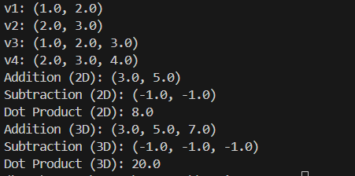

Exception Handling)

- If Vector Does not contain 2 or 3 elements
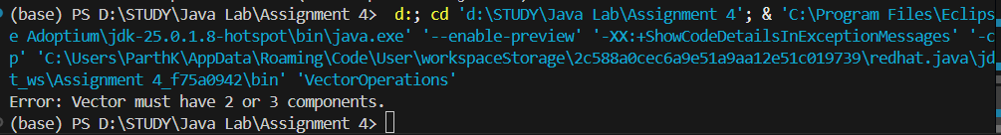

- If 2 vector are not of same Dimension and a operation is performed
